what is redux ?
redux is a libraries of react js
redux used to load data or update data via state managements
redux is a libraries so we can install redux
Redux is used to dispatch actions to store to update data
Redux is help apps scale by providing a sensible way to manage state through a unidirectional data flow model.
Redux is used to allow us to read react components data from redux store.

What is Life cycle of redux ….

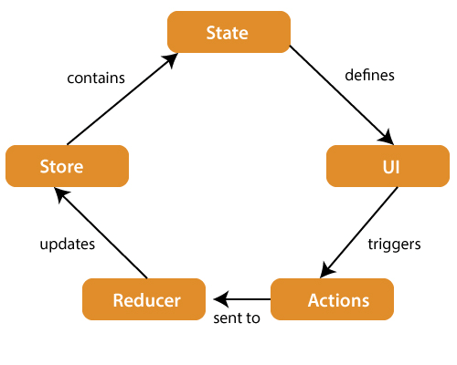

- Store : A store is a place where the entire state of your applications are listed.
It is a like a brain that is responsible for all moving parts in redux.

- Actions : A actions is sent or dispatched from the view which are payloads that can be read by reducers.
It is a pure objects created to store the information of user event.

It includes informations such as type of action , time of cocurence etc .

It cordinates with state and its aim to change something in to apps.

- Reducer : A reducer is one type of functions where we access some globals variables also.
Reducer read paylaods from action and then performed updates the stores via state.

It is a pure function to return view state from the initial state.

Advantages of Redux Libraries :
- This is a react js libraries
- Redux is unidirectional data flow
- Redux is used to for state management to update or store data.
- Redux have a dispatchers of data.
- Redux is only one store where flux is many stores systems
- Redux provides a complex architectures.
- Redux encourages a good ‘React acrhitectures’
- Redux action objects will be received and handeled directly by stores.

Create an app of counter using redux architectures …

step to install redux …..
create an app in react redux-app
Npm install all dependencies of react js
npm install redux react-redux --save
Npm install react-bootstrap bootstrap --save

Note : install or add extension in chrome a redux tools

